**Fall**

14

**wesley.y.myers@gmail.com**

Weekly Status Report

Wesley Myers

October 14-20th, 2014

08

**Fall**

Table of Contents

Executive Summary 3

Final Assembly of System 3

Laser-Camera Integration Behind 4

Interface Board Development 5

# Executive Summary

* Final Assembly of System
  + Added brackets and servo mounting plate
* Laser-Camera Integration Behind
  + Dead camera
  + Longer cable required
* Interface Board Development
  + Board layout drafted
  + Soldering to complete

# Final Assembly of System

Continued with assembly of the system. Brackets were added to the system to create a raised platform with the LRF and camera. In addition, the mounting plate for the pan-tilt servo system was added.

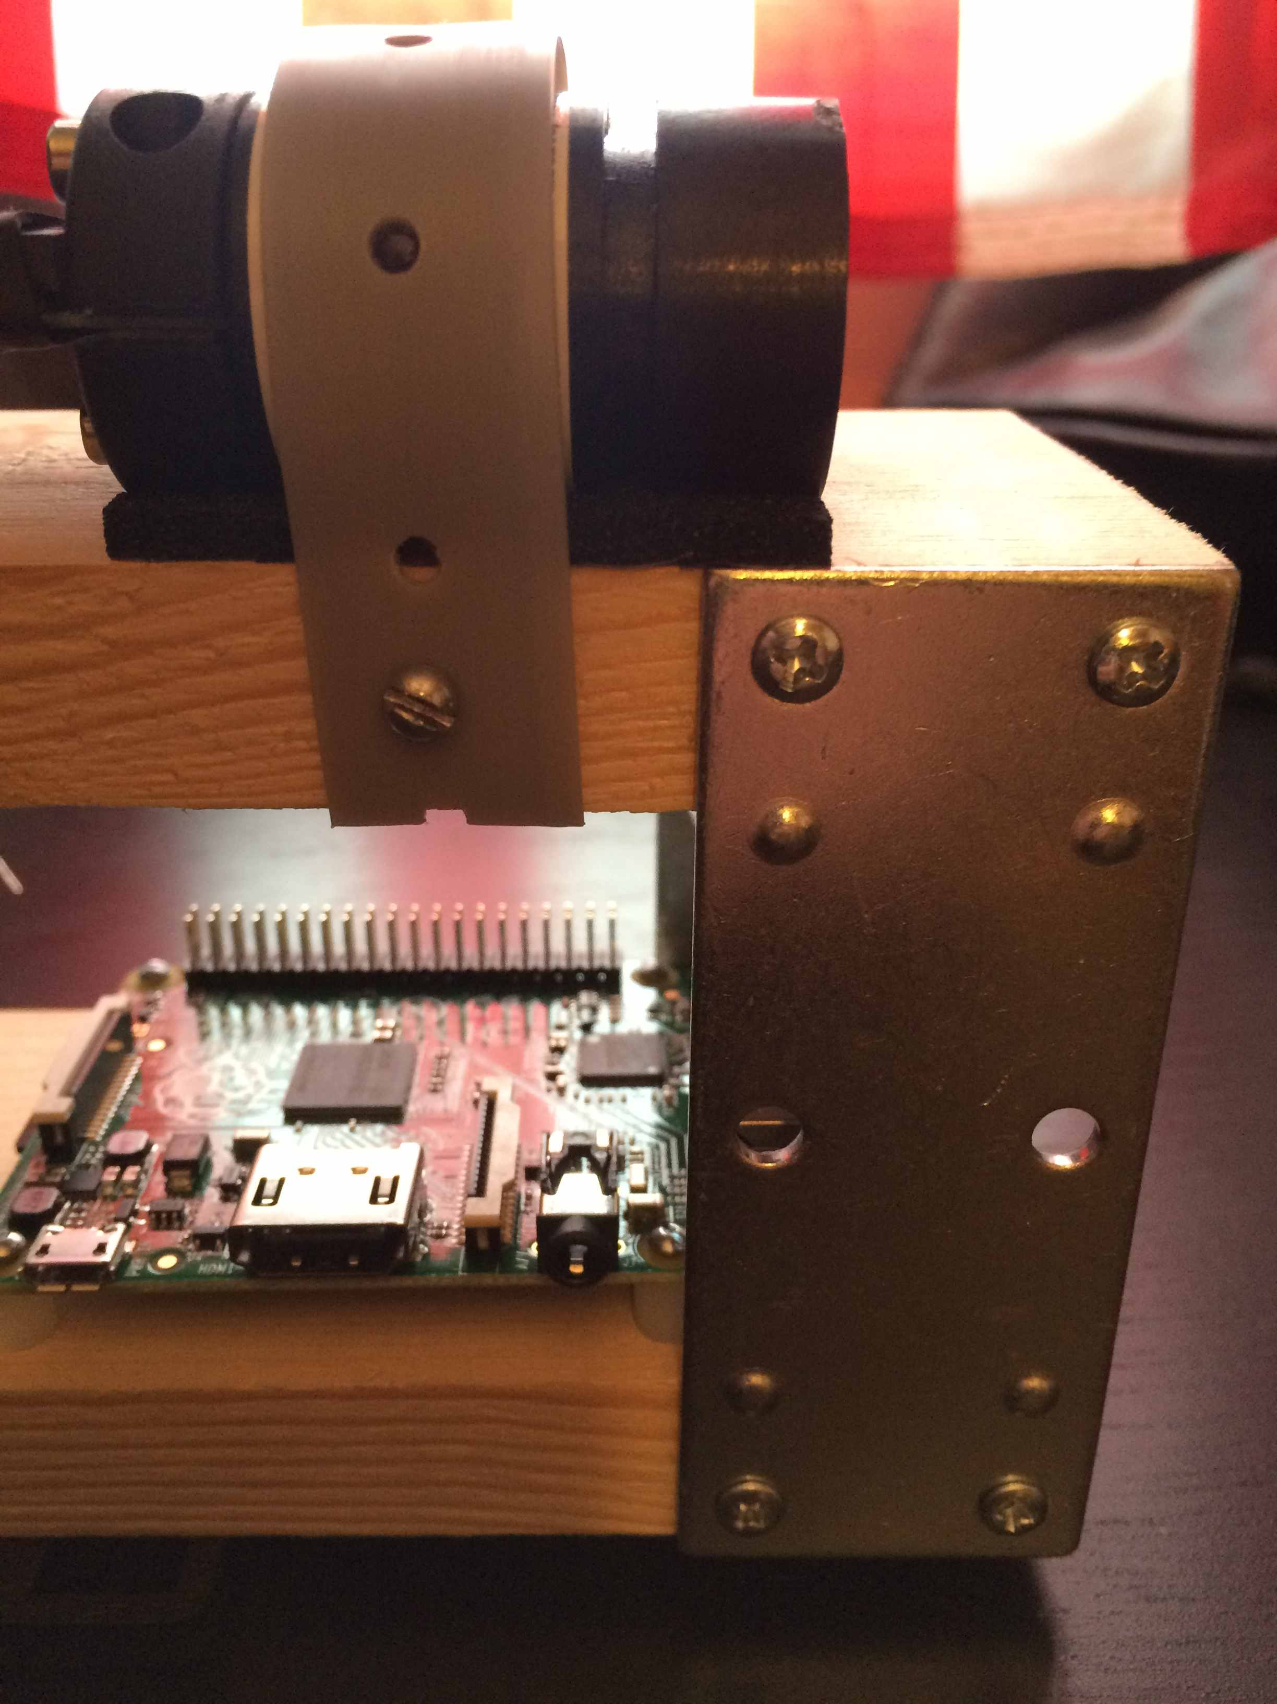

Figure - Added Bracket to Create Raised Platform

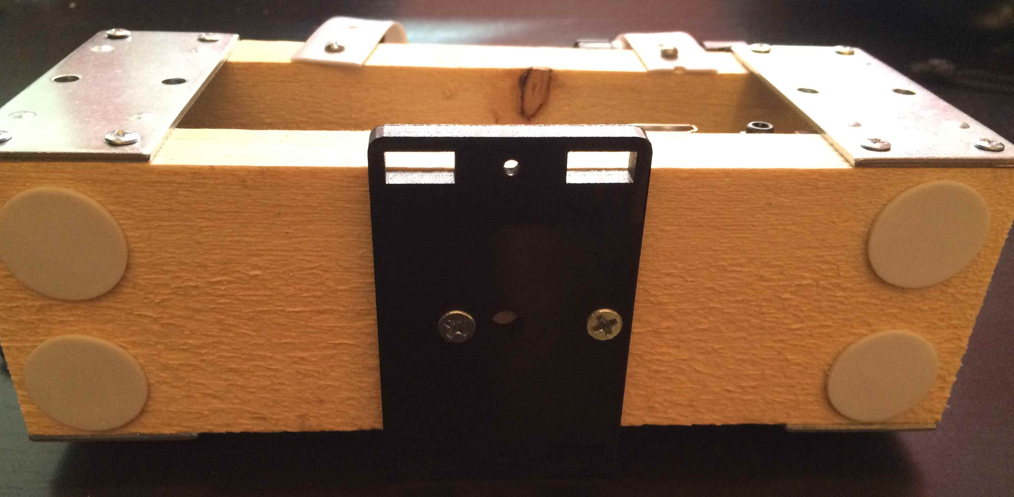

Figure - Addition of Servo Mounting Plate

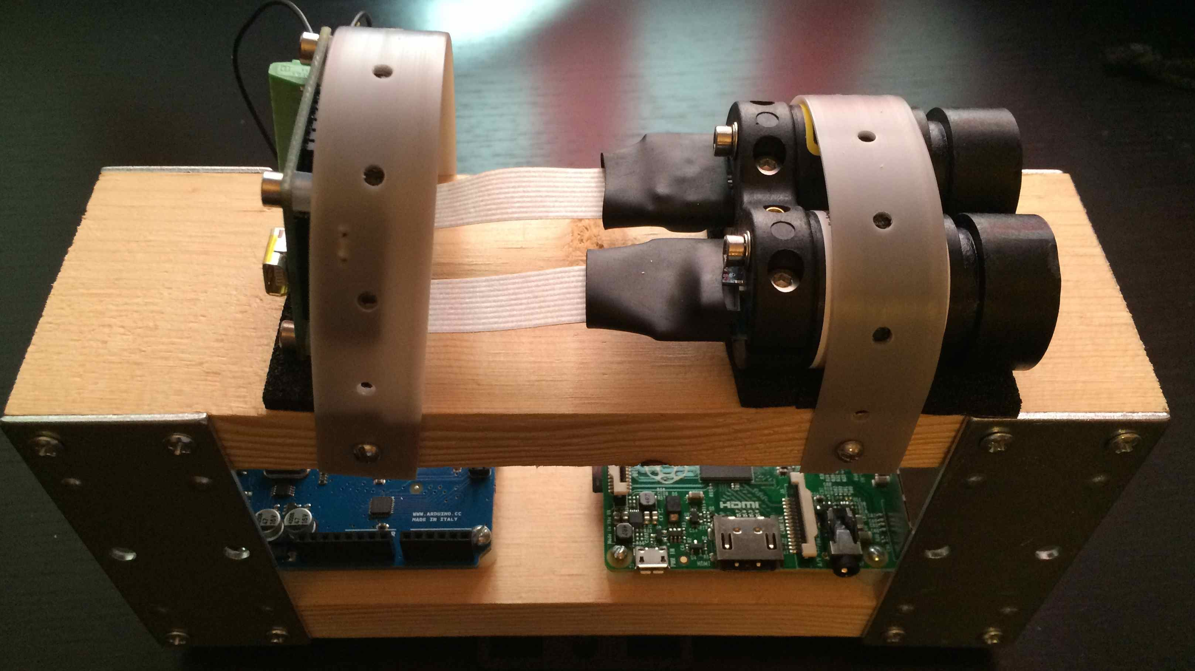

Figure - Full System

# Laser-Camera Integration Behind

A couple of issues were encountered, and then solved. The Raspberry Pi camera is known to have problems with static, meaning we can easily fry the board. In this case, the camera on hand was dead upon testing. This is possibly due to improper handling. Cameras will be ordered as back up.

The second obstacle was in the design of the system. Due to the raised platform, the 6-inch Raspberry Pi camera ribbon cable wouldn’t work. An order was placed to get 12-inch and 18-inch cables for the camera. The order arrived on October 17th and has yet to be integrated into the system due to time constraints. There is a second Raspberry Pi camera on hand; meaning as soon as time presents itself, final integration can be done.

Final assembly will have the camera on top of the LRF with the cable running the length of the system and going to the Raspberry Pi. As seen in Figure 3, the camera will be mounted to the left of the right gray strap. The cable will wrap around the system to the CSI camera port directly next to the HDMI port on the Raspberry Pi.

# Interface Board Development

The purpose of this board is so that one can easily replace boards and components without anything being soldered or being plugged in directly to the Arduino or Raspberry Pi boards. Two pieces of perf board will be used with standoffs between the two. The bottom board will interface with the Raspberry Pi. The top board will interface between the LRF, Arduino, and servos. The following diagram shows the connections that will be on the boards. The list afterwards shows the connections.

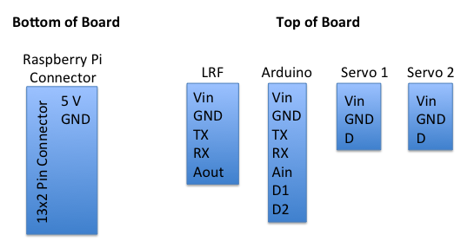

Figure - Board Layout

5V <-> Vin

LRF_TX <-> Ar_RX

LRF_RX <-> Ar_TX

LRF_Aout <-> Ar_Ain

Ar_D1 -> S1_D

Ar_D2 -> S2_D

All of the headers are present. Once time presents itself, soldering can be done to create the board.